Symposium: ‘What’s new since FOXP2: new developments in speech and language neurobiology’

Friday 7 June 2024, Leolin Price Lecture Theatre (University College London GOS Institute of Child Health, 30 Guilford Street, WC1N 1EH) (one day in-person only)
Session | Time | Topic | Speaker | Chair
 | 8:45 – 9:15am | Registration & coffee/tea on arrival
FOXP2 and the genetic basis for speech disorders – where it all began and where are we now? | 9:15 – 9:30am | Opening | A/Prof. Frederique Liegeois  University College London &  Prof. Angela Morgan  Murdoch Children’s Research Institute | A/Prof. Frederique Liegeois
 | 9:30 – 10:00am | Tracing connections between FOXP genes and speech development | Prof. Simon Fisher  Max Planck Institute for Psycholinguistics
 | 10:00 – 10:30am | TBC | Prof. Faraneh Vargha-Khadem  University College London
 | 10:30 – 11:00am | Brain basis of Childhood Apraxia of Speech from FOXP2 to now | A/Prof. Frederique Liegeois  University College London
 | 11:00 – 11:30am | Coffee break
Child speech disorder phenotypes in the context of broader neurodevelopment | 11:30 – 12:00pm | Monogenic contributions to Childhood Apraxia of Speech - lessons from the clinic | Prof. Angela Morgan (MCRI) &  Prof. David Amor  University of Melbourne | Prof. Angela Morgan
 | 12:00 – 12:30pm | Monogenic contributions to speech delay | Dr. Else Eising  Max Planck Institute of Psycholinguistics
 | 12:30 – 1:00pm | How do rare and common genetic variations lead to human disease? Lessons in epilepsy | Prof. Ingrid Scheffer  University of Melbourne
 | 1:00 – 2:00pm | Lunch break
Childhood language disorders | 2:00 – 2:30pm | Identifying genes underlying language disorders | Prof. Dianne Newbury  Oxford Brookes University | Prof. Ingrid Scheffer
 | 2:30 – 3:00pm | Integrated gene and brain mapping of language abilities | Prof. Michelle Luciano  University of Edinburgh
 | 3:00 – 3:30pm | Brain basis of developmental language disorders: recent discoveries using advanced MRI methods | Prof. Saloni Krishnan  University of London
 | 3.30 – 4:00pm | Coffee break
The future and panel discussion | 4:00 – 4:30pm | Mouse models of speech disorders – unravelling mechanisms to improve diagnosis and treatment | Prof. Michael Hildebrand  University of Melbourne | Prof. Sheena Reilly
 | 4:30 – 5:00 pm | Genetics and neurobiology of child speech and language disorders - where to next in research and clinical practice?  Questions from the audience | Panel members: Prof. Simon Fisher, Prof. Ingrid Scheffer, A/Prof. Frederique Liegeois, Prof. Michael Hildebrand
 | 5:00pm | Drinks reception

SPEAKERS
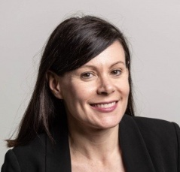 | Prof. Angela Morgan is a senior speech pathologist, NHMRC Dame Elizabeth Blackburn Fellow and leads the Speech and Language group at the Murdoch Children’s Research Institute in Melbourne, Australia. Angela is also a Dame Kate Campbell Professorial Fellow of the University of Melbourne. Her expertise is in the diagnosis of child speech disorders. She is Director of the Speech Apraxia and Genetics Clinic at the Royal Children’s Hospital. Angela leads the Centre of Research Excellence – Translational Centre for Speech Disorders.
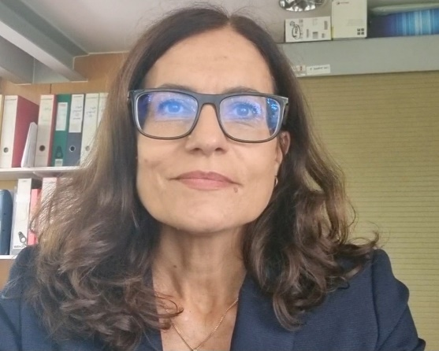 | A/Prof. Frederique Liegeois is a cognitive neuroscientist and head of the Clinical System Neuroscience Section at the University College London (UCL) Great Ormond Street Institute of Child Health, one of the world’s leading institutions in paediatric research. Frederique is internationally renowned for her work on the neural bases of inherited and acquired communication disorders. She combines neuropsychological and speech-language phenotyping with advanced brain MRI analyses to unravel potential mechanisms at the root of communication challenges in individuals with rare genetic variations, as well as in young people with more prevalent conditions (e.g. brain injury, preterm birth).
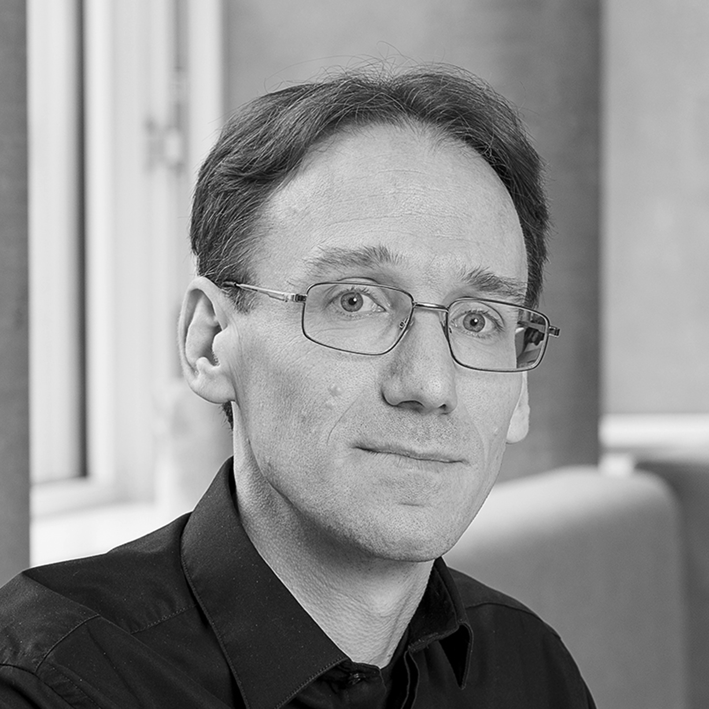 | Prof. Simon E. Fisher is director of the Max Planck Institute for Psycholinguistics and Professor of Language and Genetics at the Donders Institute for Brain, Cognition and Behaviour, in Nijmegen, the Netherlands. Simon's research focuses on molecular mechanisms involved in human speech and language abilities. His work has an interdisciplinary perspective, integrating data from genetics/genomics, psychology, neuroscience, developmental biology and evolutionary anthropology.
 | Prof. Faraneh Vargha-Khadem
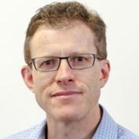 | Prof. David Amor is an internationally recognised consultant clinical geneticist and clinician scientist with a research focus on human genetic disorders. David is a Galli Chair in Developmental Medicine in the Department of Paediatrics, University of Melbourne, Australia. He is also a Research Group Leader of Neurodisability & Rehabilitation at the Murdoch Children’s Research Institute.
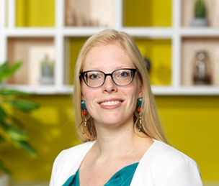 | Dr. Else Eising is a post-doctoral researcher in the Language and Genetics Department, Max Planck Institute for Psycholinguistics in Nijmegen, the Netherlands. Her work focuses on the genetics of speech and language-related traits and disorders, with a main focus on stuttering. Else is also involved in various ‘gene hunting’ projects searching rare variants that cause rare speech disorders, and in genome wide association studies searching common variants associated with language, reading and musicality-related traits.
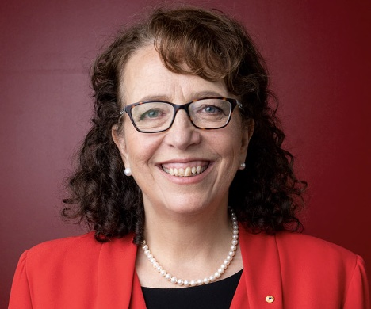 | Laureate Prof. Ingrid Scheffer AO is a physician-scientist whose work as a paediatric neurologist and epileptologist at the University of Melbourne and Florey Institute has led epilepsy genetics research over 25 years. In collaboration with Professor Samuel Berkovic and molecular geneticists, they identified the first epilepsy gene and many genes subsequently. She led the first major International League Against Epilepsy revision of the classification of epilepsies in 28 years (March 2017) and was a co-recipient of the Australian Prime Minister’s Prize for Science and in 2018 was elected to the Royal Society (London).
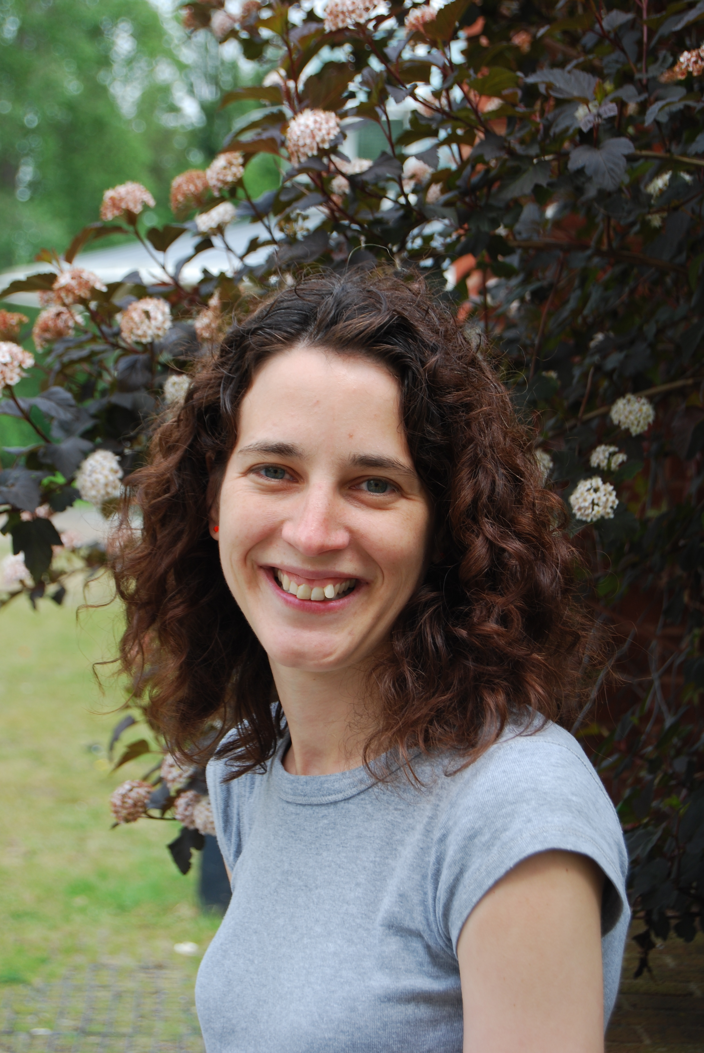 | Prof. Dianne Newbury is a molecular geneticist and senior lecturer in the Department of Biological and Medical Sciences at Oxford Brookes University. Her areas of expertise are gene mapping (linkage, association, sequencing), speech and language disorders and neurodevelopmental disorders. Dianne is also a principal investigator of a Research Lab at Oxford Brookes University investigating developmental speech and language disorders and the neurogenetic processes underlying speech and language development.
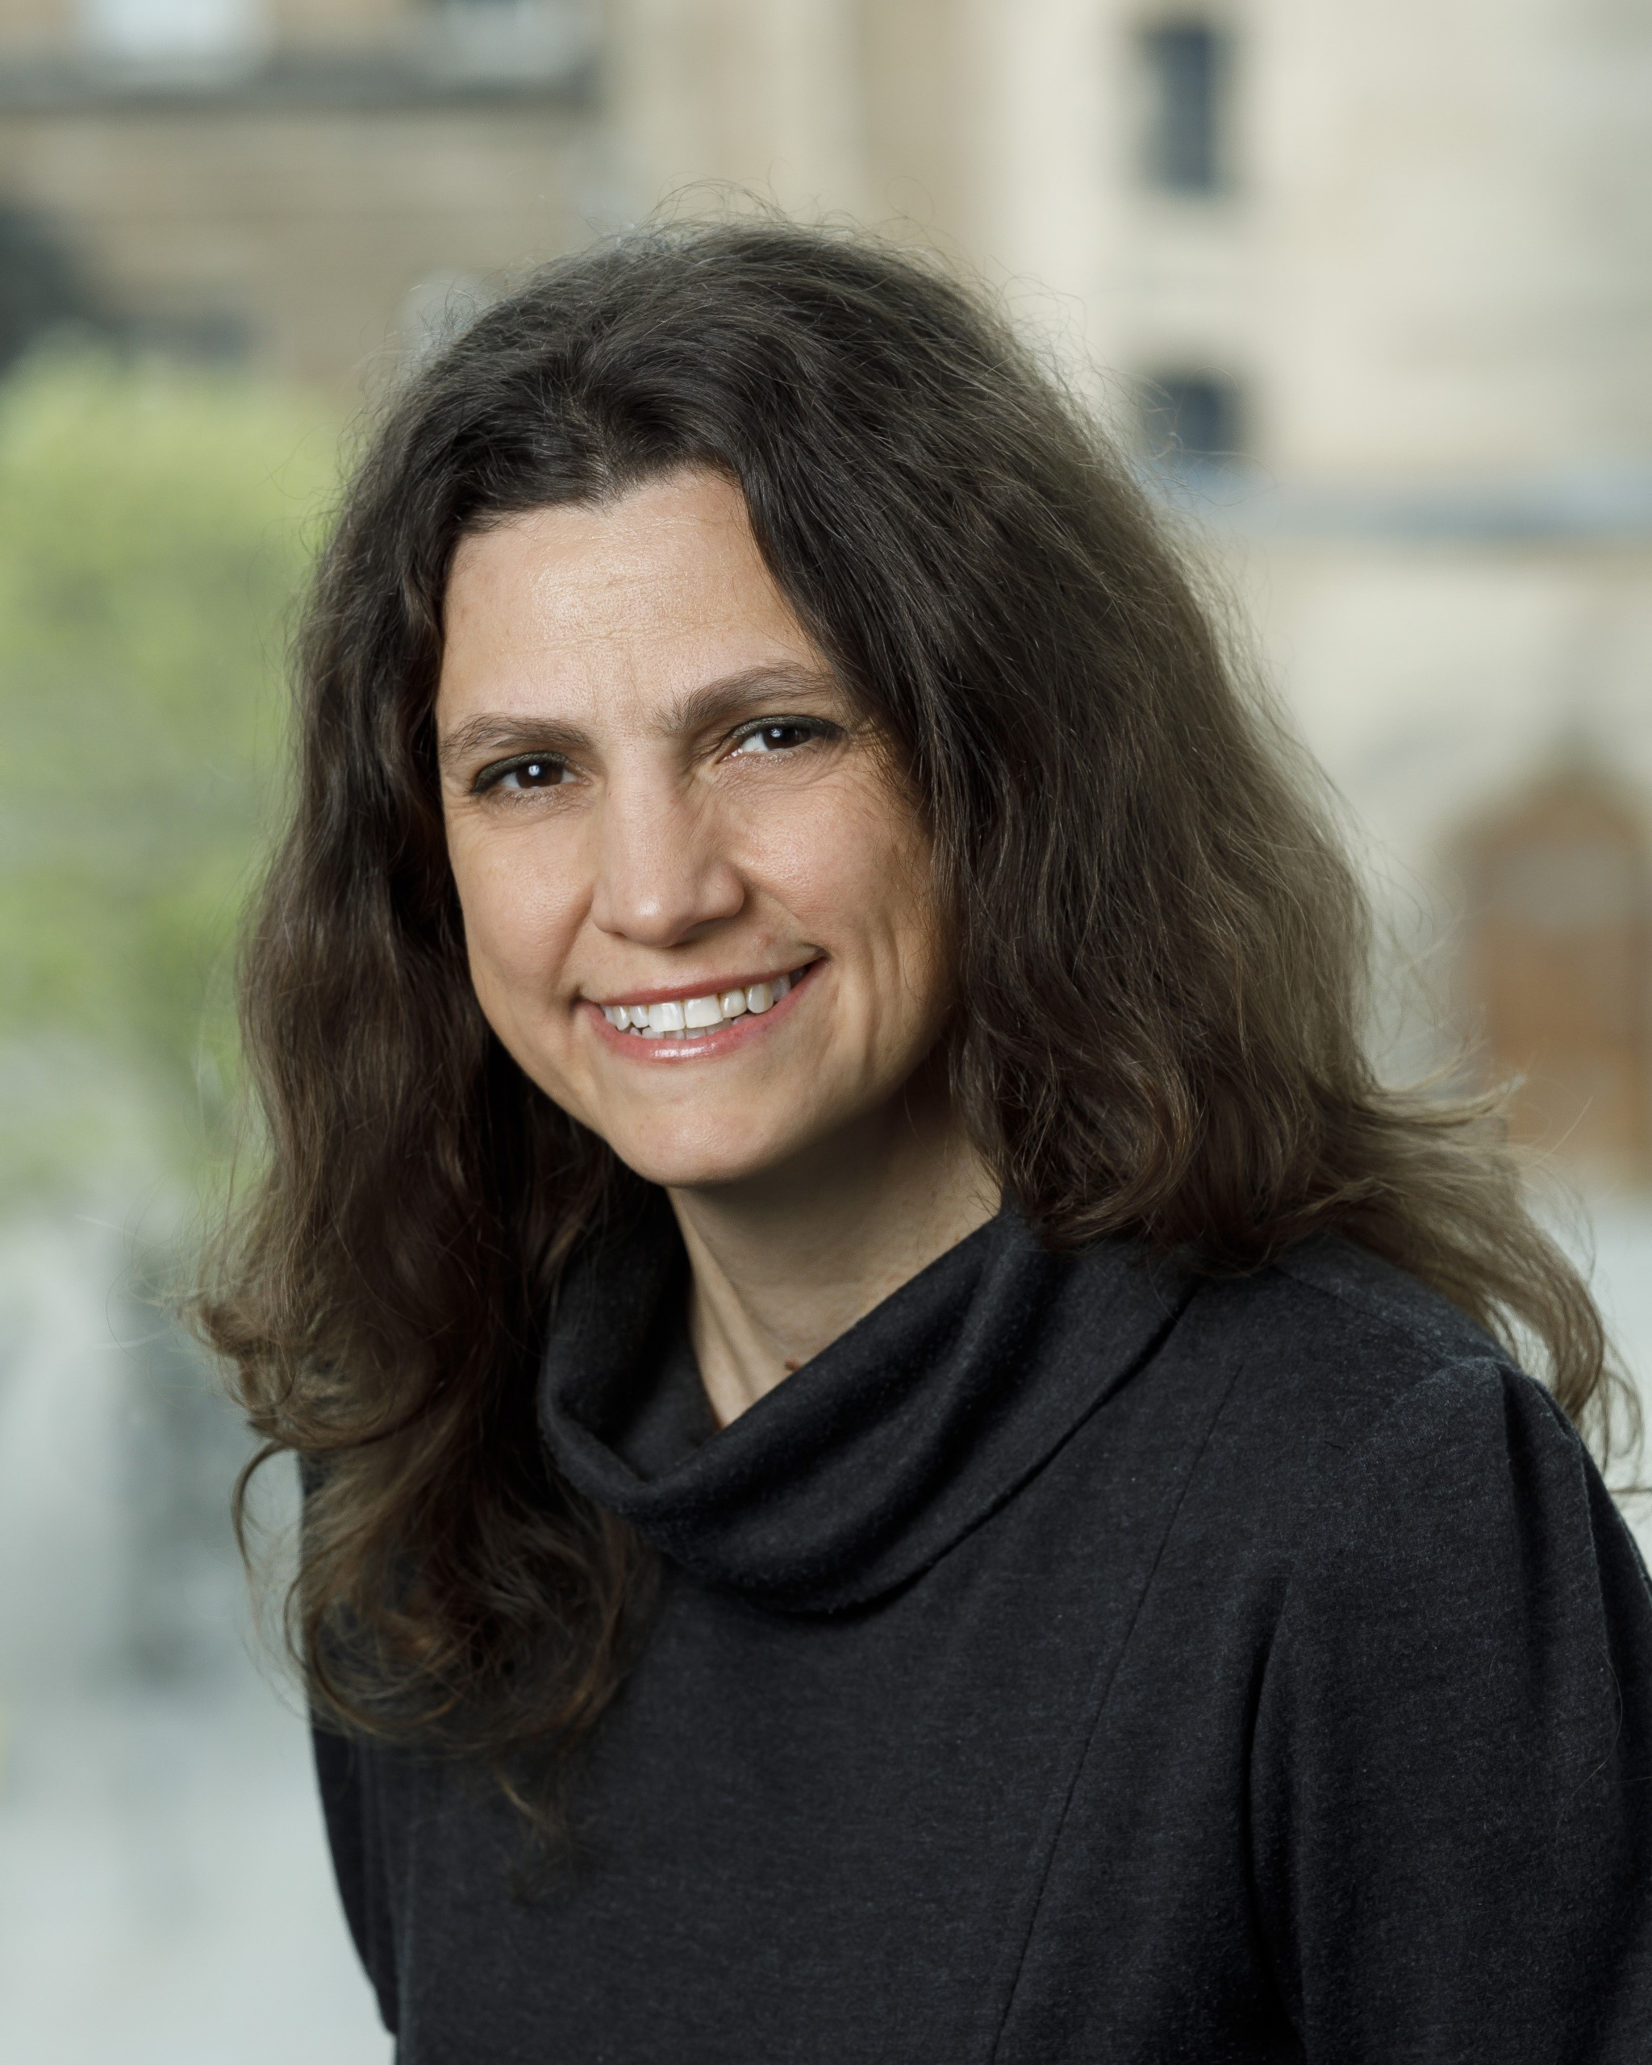 | Prof. Michelle Luciano is a Personal Chair of Behavioural Genetics, School of Philosophy, Psychology and Language Sciences, University of Edinburgh, Scotland. Michelle use twin and family modelling to investigate the relative influence of genes and environment on behavior, genome-wide association techniques for gene discovery, plus other analyses to explore the effects of rare and structural genetic variants, gene methylation and biological pathways. She is also interested in the interaction between measured environmental variables with genes.
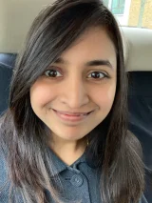 | Prof. Saloni Krishnan is developmental cognitive neuroscientist and professor of cognitive neuroscience at Royal Holloway, University of London where she leads the Neuroscience of Communication Development lab (N-CoDe lab). Her research is focused on identifying how the brains of those with childhood speech and language disorders (such as developmental language disorder, dyslexia, and stuttering) differ from those without these disorders.
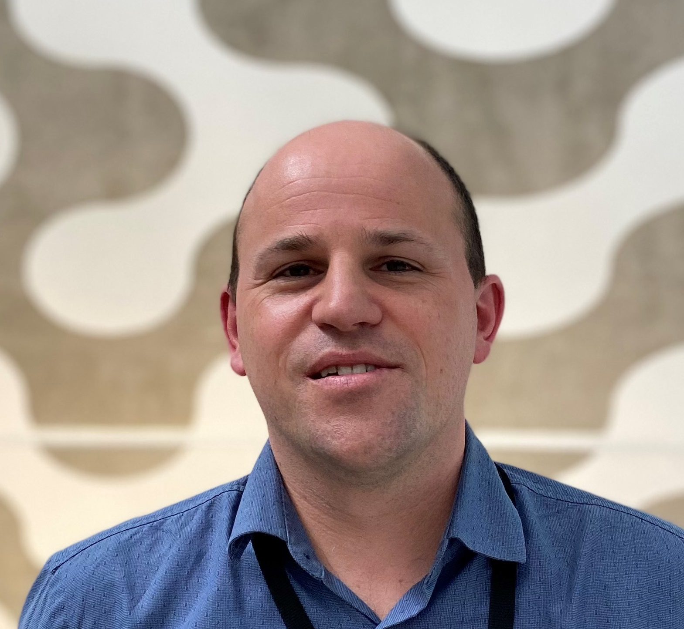 | Prof. Michael Hildebrand is a molecular geneticist in the Department of Medicine, University of Melbourne, Australia with a well-established track record in applying genetic and functional approaches to elucidate novel pathways involved in human disease. Michael’s focus for the past decade has been discovery and characterisation of speech disorder, epilepsy, vascular malformation, and deafness genes.

