Child Speech Disorders: translating cutting-edge science into clinical practice

Symposium Program (in-person only): Monday 9 October 2023

Ella Latham Auditorium (first floor entry) – The Royal Children’s Hospital, Melbourne

Session 1: Speech Pathology diagnosis, therapy and scope of practice in Genetics
9:00 – 9:05am | Welcome  Prof. Angela Morgan
9:05 – 9:35am | How can I tell if a child is having a seizure?  Prof. Ingrid Scheffer
9:35 - 10:05am  10:05-10:30am | Why bother with genetics?  Prof. David Amor  Exploring Barriers and Enablers to Genetics and Genomics in Speech Pathology
Clinical Practice
Ms. Mariana Lauretta

10:30 - 10.55am | Morning tea
10:55 - 11:20am | Developing a new digital assessment and analysis speech tool – ADAAPT  (Assessment of Dysarthria, Articulation, Apraxia, Phonology with Treatment  planning)  Ms. Olivia van Reyk and Ms. Charlotte Boulton
11:20-11:45am  11:45 – 12:00pm | Speech and language conditions with regression: how to support and plan for  the future  Ms. Lottie Morison  Childhood Apraxia of Speech: a parent’s journey  Ms. Sarah Mackintosh
12:00 – 13:00pm | LUNCH

Session 2: Latest advances in Speech Pathology research
13:00 - 13:15pm | Opening address: Precision medicine in child health  Prof. Kathryn North
13:15 - 13:55pm  13:55 – 14:25pm | Genetics in Speech Pathology Clinical Practice  Prof. Angela Morgan  Psychosocial features of stuttering for school-aged children: a review and  implications for practice  Ms. Georgie Johnson
14:25 - 14:55pm | A new gene pathway for developmental stuttering  Prof. Michael Hildebrand
14:55 - 15:25pm | Afternoon tea
15:25 - 15:55pm | Brain basis of Childhood Apraxia of Speech  A/Prof. Frederique Liegeois
15:55 – 16:25pm | SpeechATAX: a multinational randomised controlled trial of Dysarthria  Prof. Adam Vogel
16:25 – 16:45pm  16:45pm - | Josh Earl  Closing address, reception and drinks

SPEAKERS
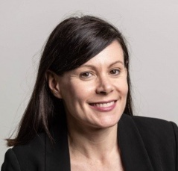 | Prof. Angela Morgan is a speech pathologist, NHMRC Dame Elizabeth Blackburn Fellow and leads the Speech and Language group at the Murdoch Children’s Research Institute. Angela is also a Dame Kate Campbell Professorial Fellow of the University of Melbourne. Her expertise is in the diagnosis of child speech disorders. She is Co-Director of the Speech Apraxia and Genetics Clinic at the Royal Children’s Hospital with Prof. Amor. Angela leads the CRE – Translational Centre for Speech Disorders.
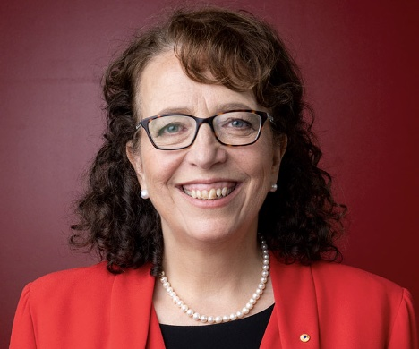 | Prof. Ingrid Scheffer AO is Laureate Professor of Paediatric Neurology, University of Melbourne and Honorary Research Fellow at the Florey and Murdoch Children’s Research Institutes. Ingrid is a paediatric neurologist and epileptologist and her collaborative research group was the first to discover a gene for epilepsy. Her research focuses on epilepsy syndromology and classification, and genetics of the epilepsies and speech and language disorders. She is President of the Australian Academy of Health and Medical Sciences.
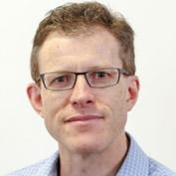 | Prof. David Amor is an internationally recognised consultant clinical geneticist and clinician scientist with a research focus on human genetic disorders. David is a Galli Chair in Developmental Medicine in the Department of Paediatrics, University of Melbourne. He is Co-Director of the Speech Apraxia and Genetics Clinic at the Royal Children’s Hospital with Prof. Morgan.
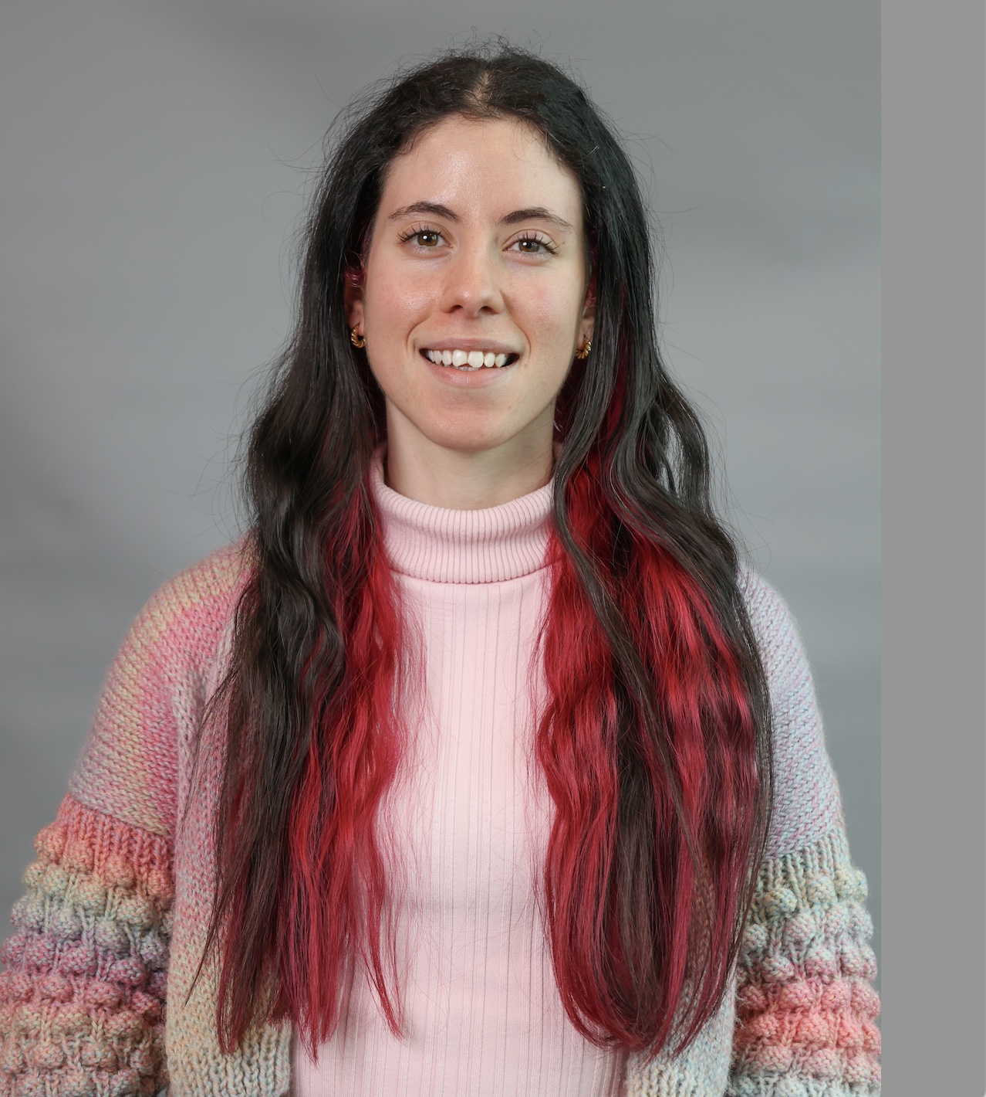 | Ms. Mariana Lauretta is an Associate Genetic Counsellor and Certified Practicing Speech Pathologist, currently working as a research assistant with the Speech and Language Group at Murdoch Children’s Research Institute. She has a keen interest in translational genomics, particularly related to supporting non-traditional genetics service users to incorporate genetics and genomics into everyday clinical practice.
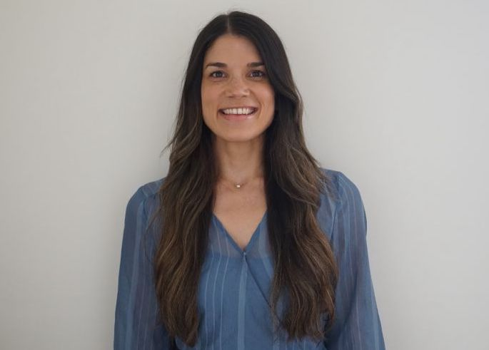 | Ms. Olivia van Reyk is a speech pathologist and research officer with expertise in speech and language phenotyping. She coordinates a population-based study collecting normative data in school and early learning settings for the development of a digital speech assessment tool, as well as natural history studies in rare genetic conditions.
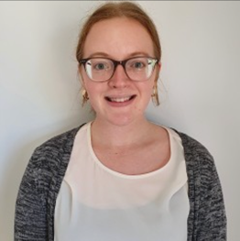 | Ms. Charlotte Boulton is a speech pathologist and research assistant with the Speech and Language group. She has worked in both clinical and research settings, with an interest in speech sound disorders and early language development.
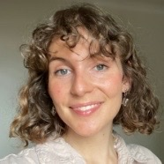 | Ms. Lottie Morison is a speech pathologist and research assistant. Lottie has worked in clinical and research settings as a speech pathologist. Lottie's areas of interest include motor speech disorders, augmentative and alternative communication, and early language and literacy development. Lottie is also a PhD student at the University of Melbourne.
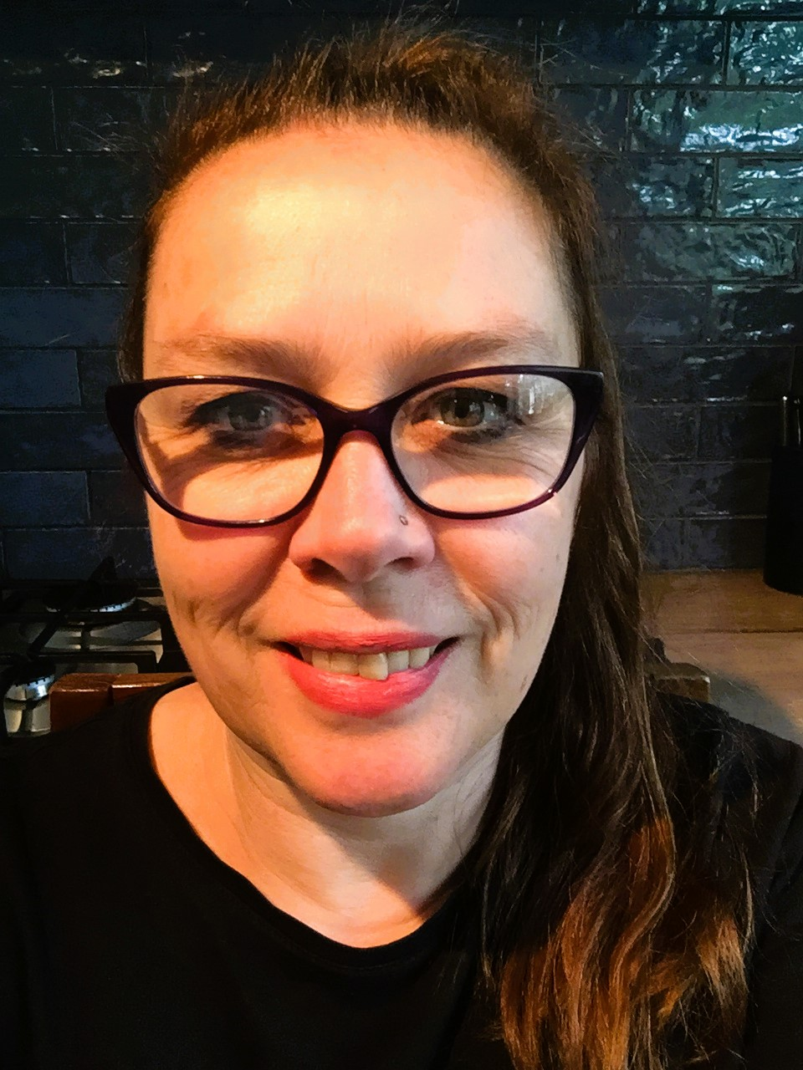 | Ms. Sarah Mackintosh is the proud mum of 2 children, the youngest of whom has attended speech therapy since the age of 2. When he was 4, genetic testing detected a disruption of the FOXP2 gene. Due to their experience with severe apraxia of speech, Sarah is now studying Bachelor of Speech Pathology.
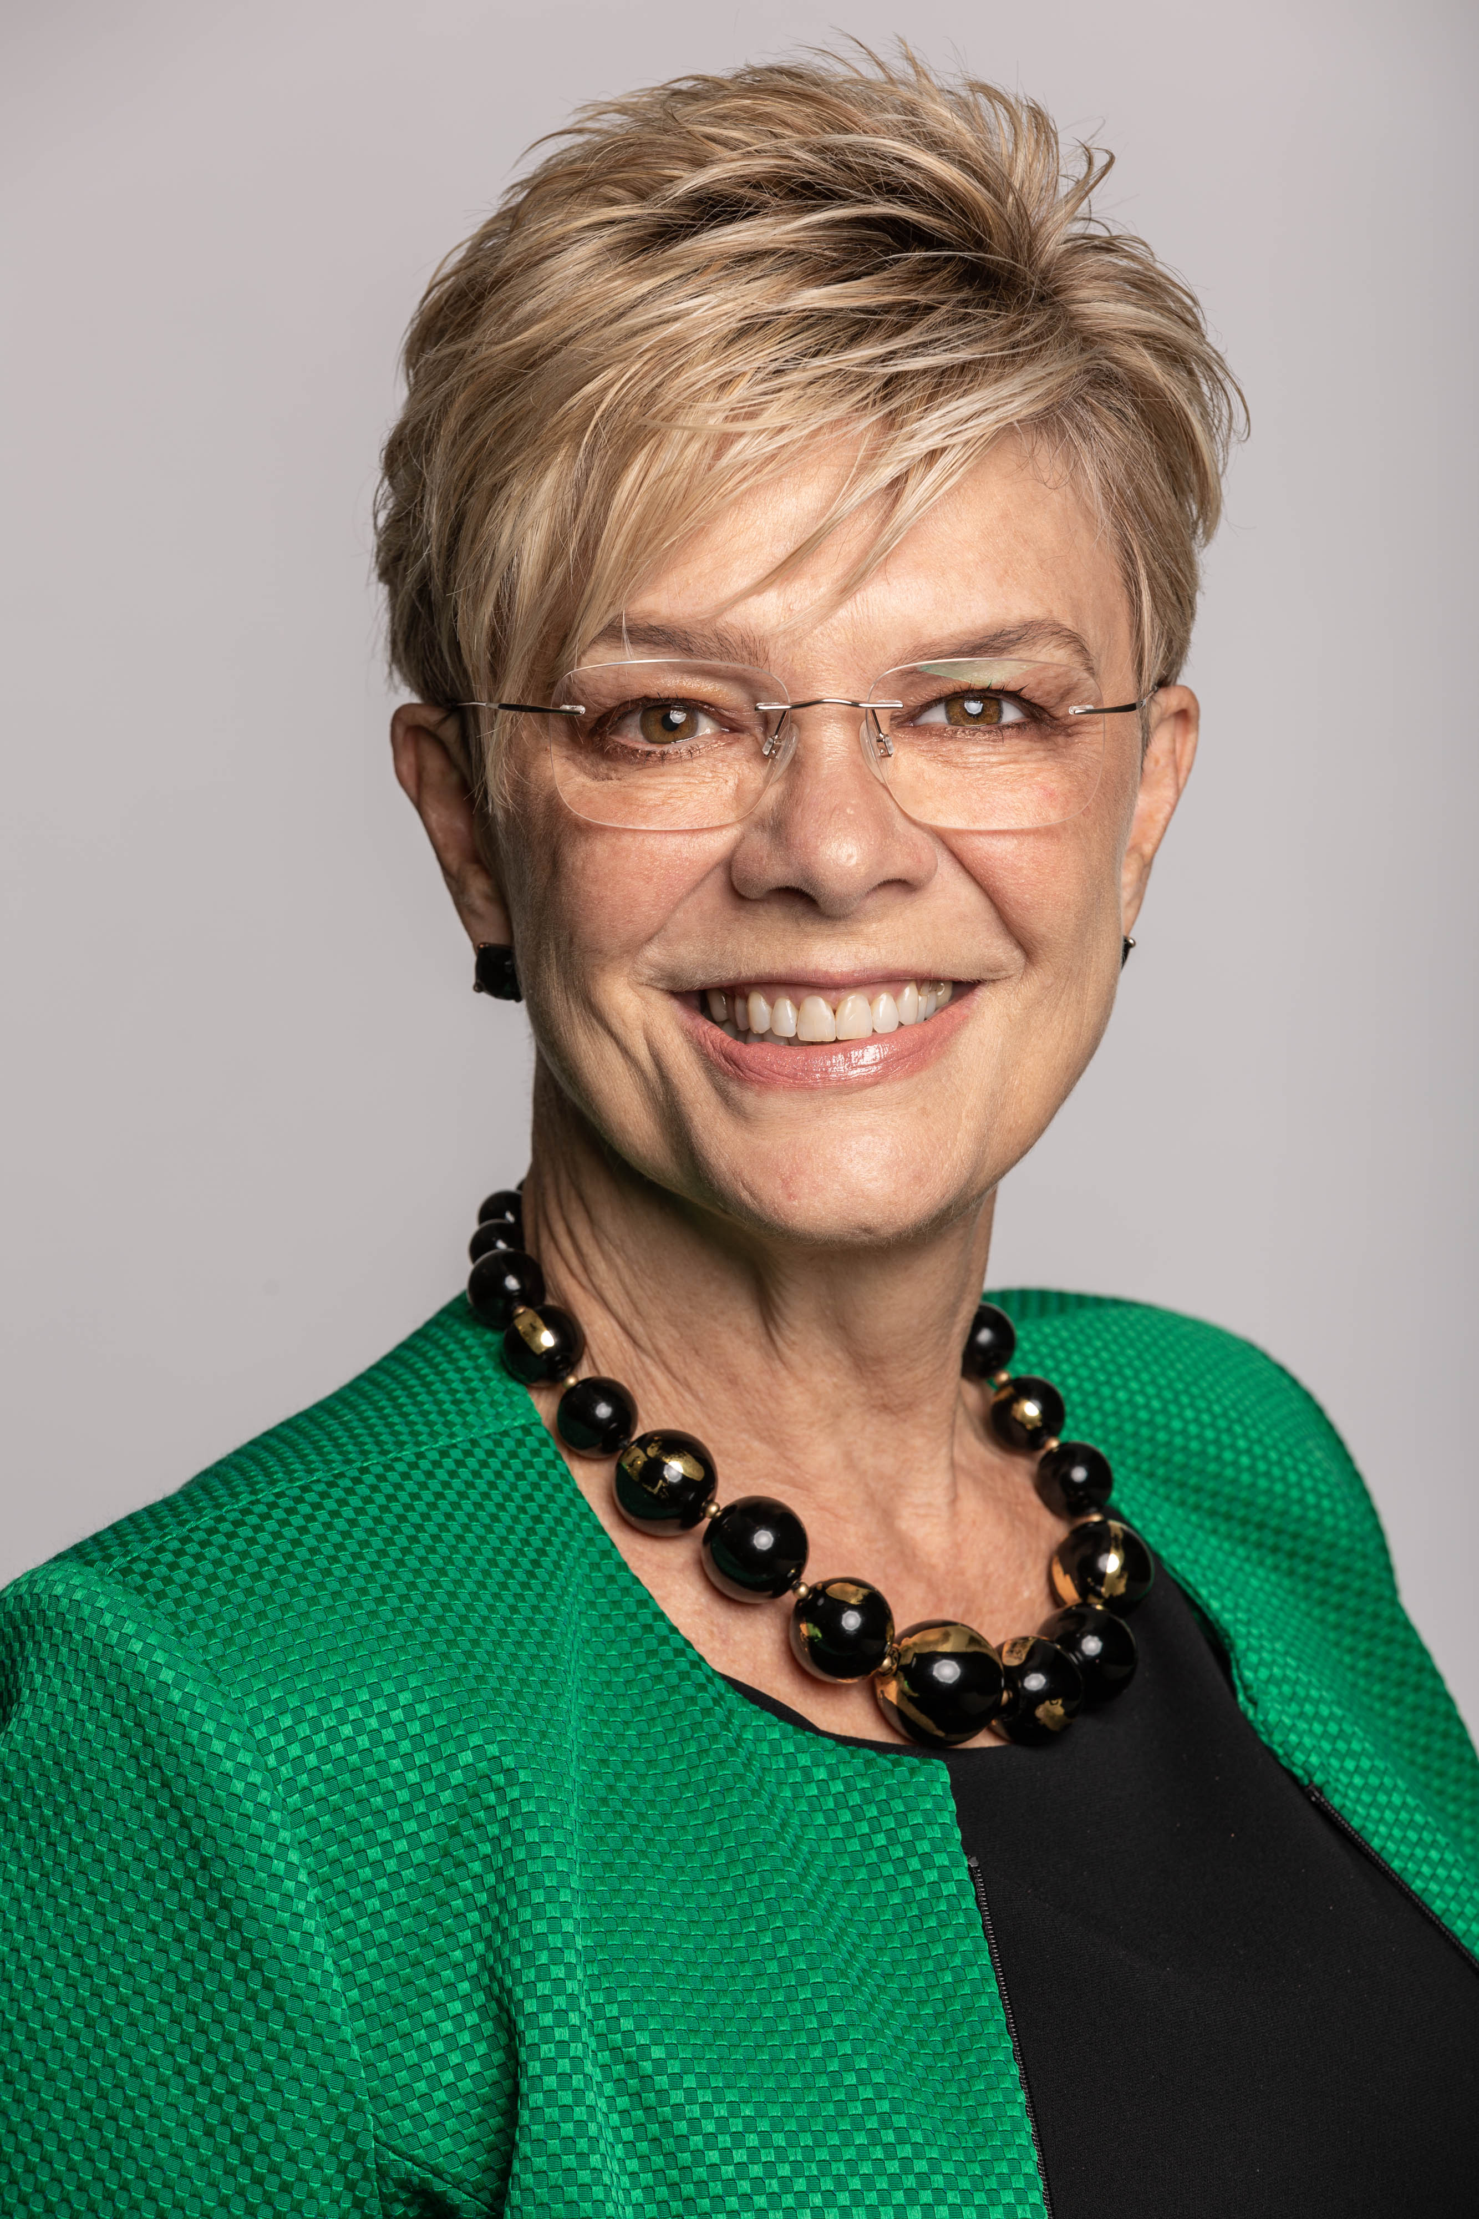 | Prof. Kathryn North is Director of the Murdoch Children’s Research Institute and the David Danks Professor of Child Health Research at the University of Melbourne. Kathryn is a clinician-scientist, trained as a paediatrician, neurologist and geneticist. At MCRI, Kathryn leads a diverse team of over 1500 researchers with a dedicated focus to improve the health and wellbeing of children and their families. Kathryn is a national and global leader in genomic medicine. She leads Australian Genomics, a national network of over 100 institutions around Australia, with the goal of developing evidence and practical strategies to embed genomic medicine in the Australian health system.
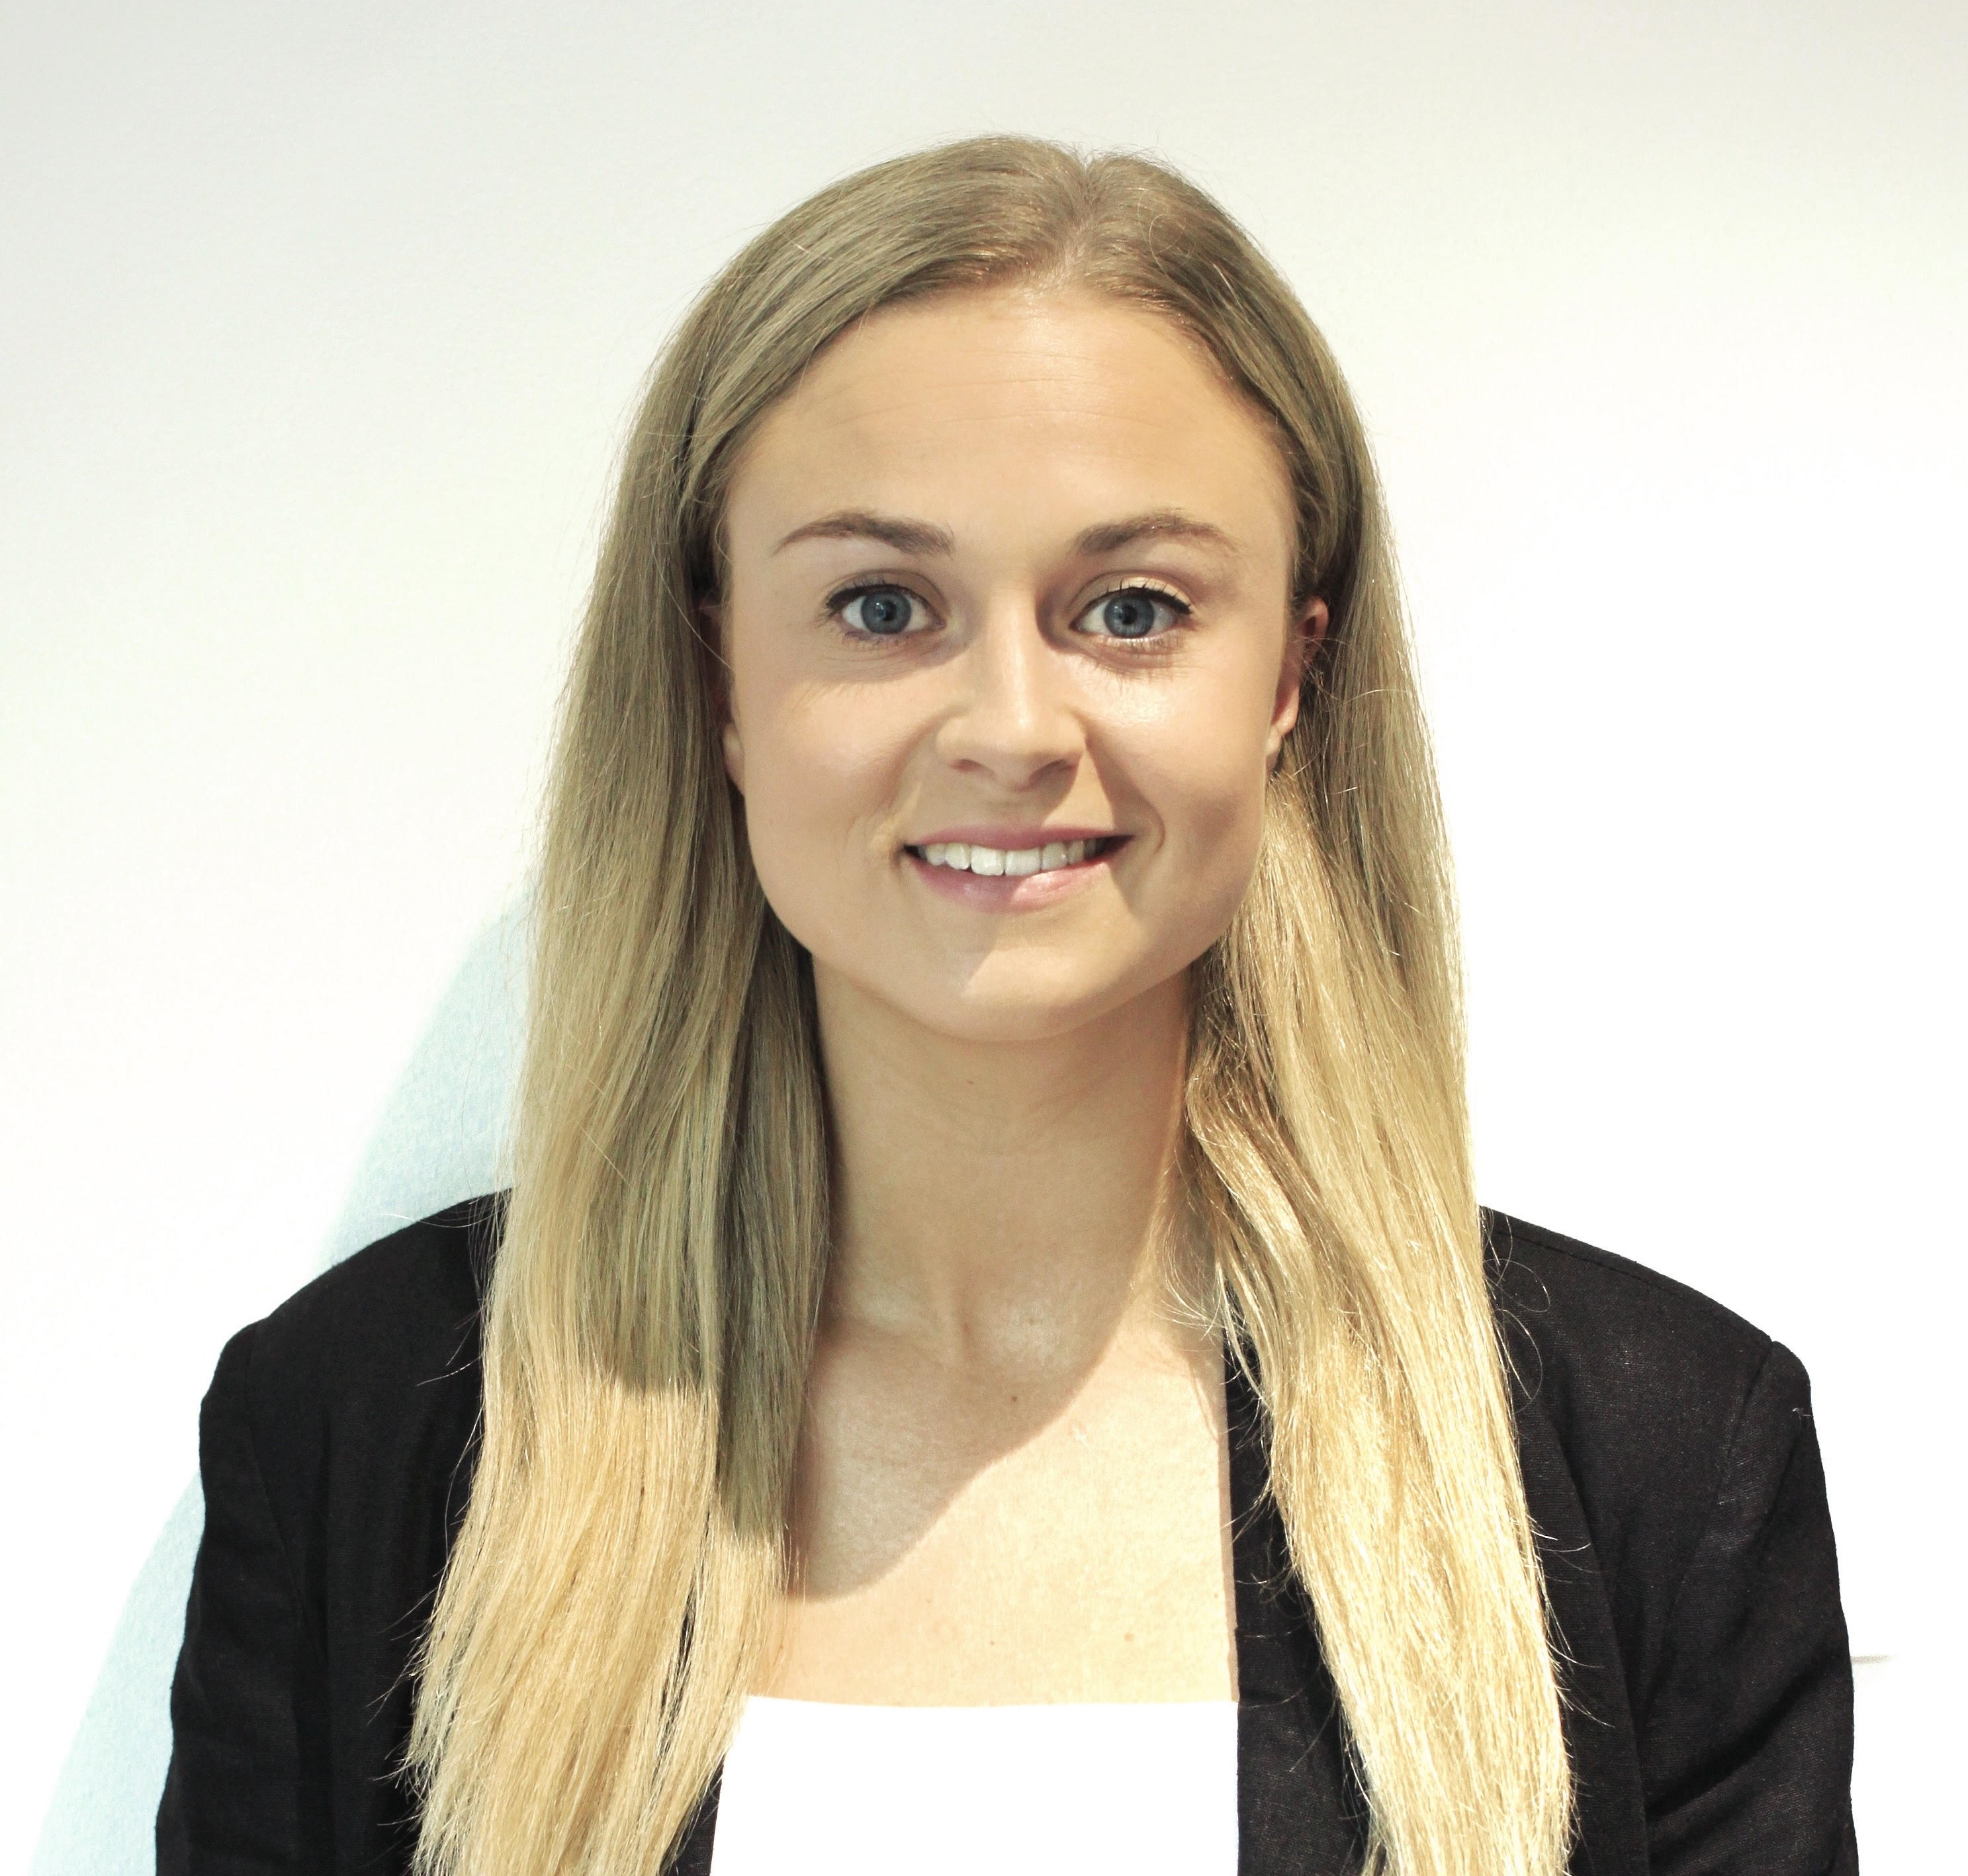 | Ms. Georgie Johnson is a speech pathologist, PhD candidate and Lecturer at the University of Melbourne. Georgie has worked clinically in private practice and school-based settings prior to commencing her research. She is also the Social Media Community Director and Camp Director for the Stuttering Association for the Young, Australia (SAY: AU). Her specialty area of interest is childhood stuttering, specifically management options for school-age children.
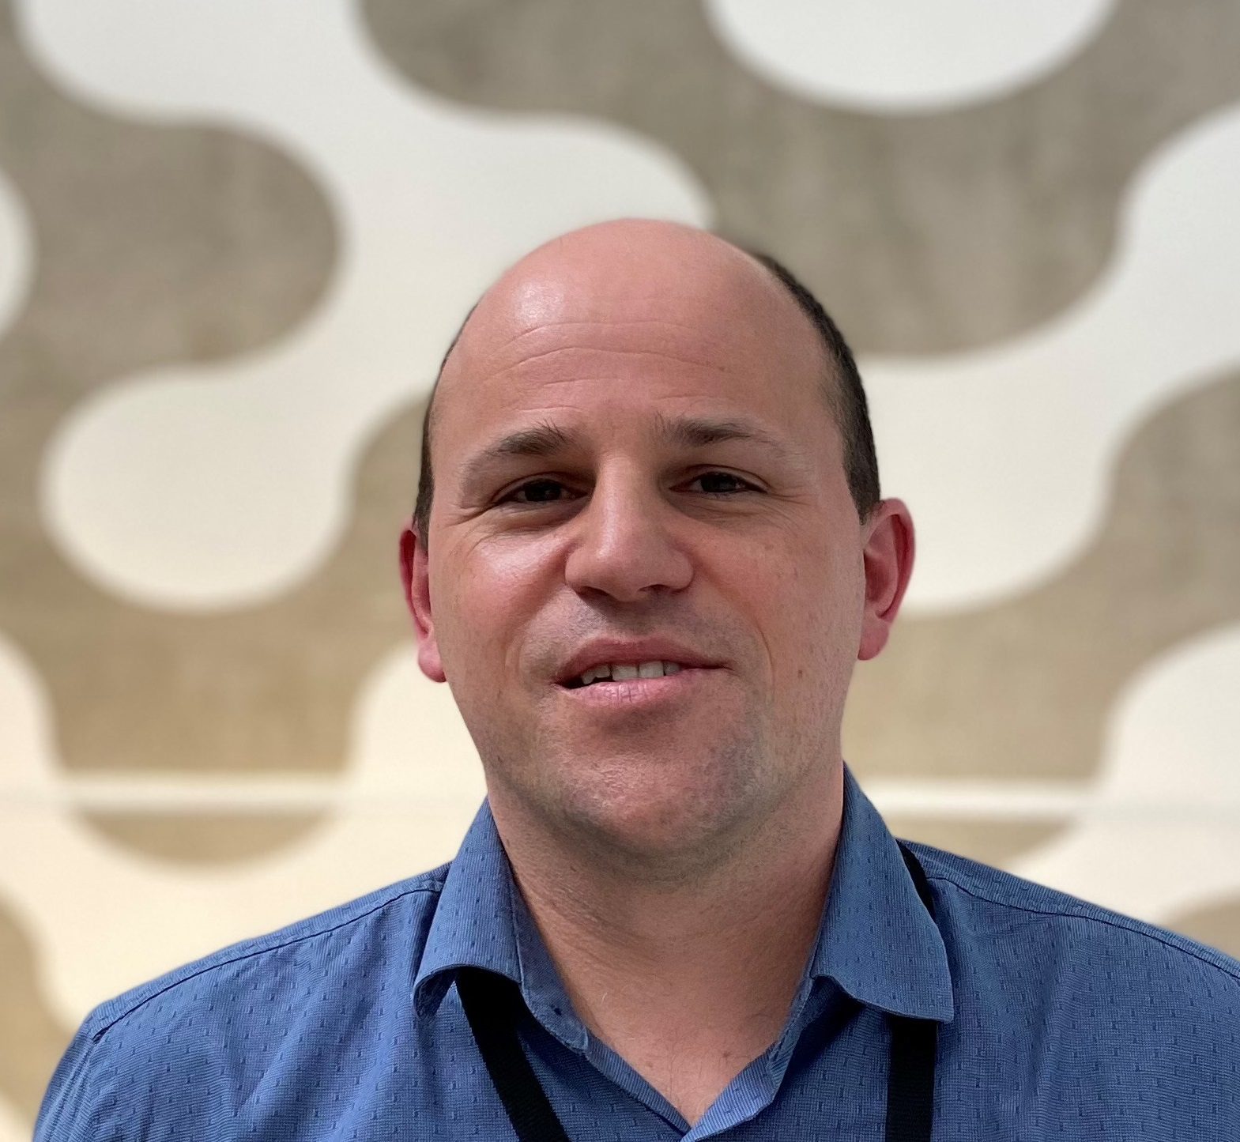 | Prof. Michael Hildebrand is a molecular geneticist with a well-established track record in applying genetic and functional approaches to elucidate novel pathways involved in human disease. Michael’s focus for the past decade has been discovery and characterisation of speech disorder, epilepsy and deafness genes.
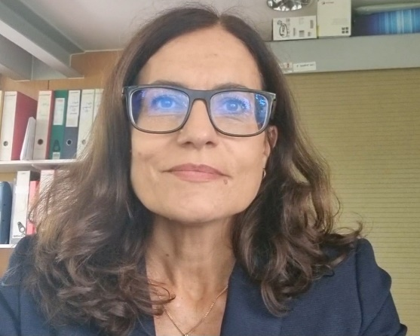 | A/Prof. Frederique Liegeois is a cognitive neuroscientist and head of the Clinical system Neuroscience Section at the UCL Great Ormond Street Institute of Child Health, one of the world’s leading institutions in paediatric research. Frederique is internationally renowned for her work on the neural bases of inherited and acquired communication disorders.
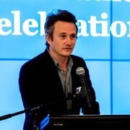 | Prof. Adam Vogel is Professor of Speech Science in the School of Health Sciences and Head of Speech Pathology at The University of Melbourne. He is an Australian Research Council Future Fellow and Humboldt Fellow at the Hertie Institute for Clinical Brain Research, University of Tübingen, Germany. Adam is also Chief Science Officer of Redenlab Inc, a neuroscience technology company using speech and language biometrics to enhance decision making in clinical trials.
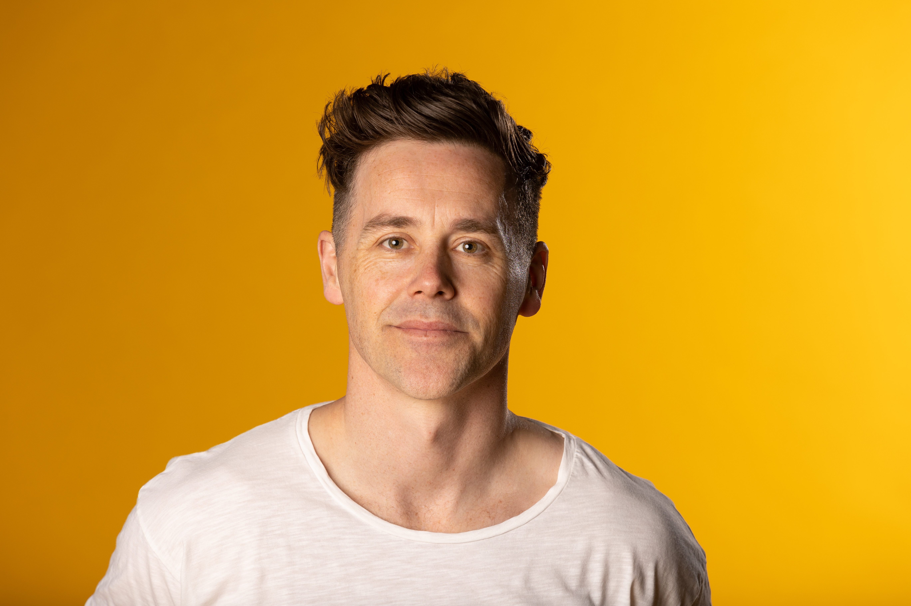 | Mr. Josh Earl is a Melbourne based stand-up comedian. Josh is well known for his work in stand-up comedy, radio and television. He openly talks about his speech difficulties in his stand-up routine and is an advocate for individuals with speech disorder.

